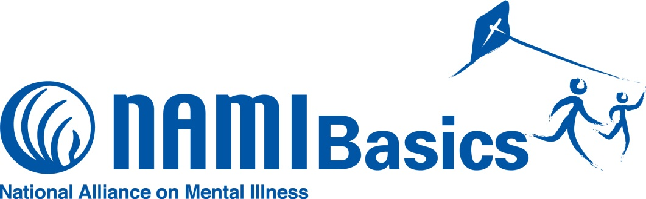

**What is the NAMI Basics Education Program?**

NAMI Basics is a free, six-session program designed for parents and other family caregivers of children and adolescents with emotional and behavioral difficulties. NAMI Basics helps parents and other family caregivers of children to understand the illnesses that are causing those behavioral difficulties, and the critical role families play in the treatment of those illnesses. The program is taught by trained teachers who are also the parents or family caregivers of individuals who experienced emotional or behavioral difficulties prior to age 13.

**Spring Class Forming Now!**

NAMI Arapahoe/Douglas Counties, the local chapter of the National Alliance on Mental Illness, will offer its **NAMI Basics Education Program beginning Monday, April 3, 2017 and continuing through May 8. There is no cost to attend but registration is required. For more information, contact** [**outreach@namiadco.org**](mailto:outreach@namiadco.org)**. or 303-991-7688.**

**Participant Perspectives**

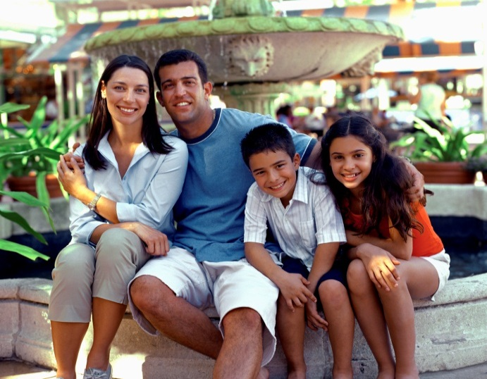

“This is such a great step by step program that walks parents every step of the way. It is as if you are holding their hand through it all.”

“The course is inclusive of almost all aspects of family and child resources. I could have spent a lifetime getting all this information on my own. I feel supported, strong and ready to go forward.”

“NAMI Basics bridges the gap. It provides help that can’t be found in a doctor’s office.”

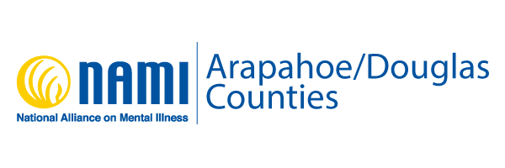

**NAMI Arapahoe/Douglas Counties**

**155 Inverness Drive West, Ste. 205**

**Englewood CO 80112**

**303-991-7688**

**www.namiadco.org**

**About NAMI**

NAMI, the National Alliance on Mental Illness, is the nation’s largest grassroots mental health organization dedicated to building better lives for the millions of Americans affected by mental illness. NAMI Arapahoe/Douglas Counties is an affiliate of NAMI CO. Our dedicated volunteer members and leaders work tirelessly to raise awareness and provide essential education, advocacy and support group programs for people in our community living with mental illness and their loved ones.